Software Engineering
Project Progress Report – Phase II
Project Title: Prompt Injection Detection
Students Details
SAP ID | Roll Number | Name of the Student
70102400069 | K017 | Shripad Jadhav
70102400071 | K032 | Debayan Lahiry
70102400036 | K049 | Sarah Samel

Block Diagram
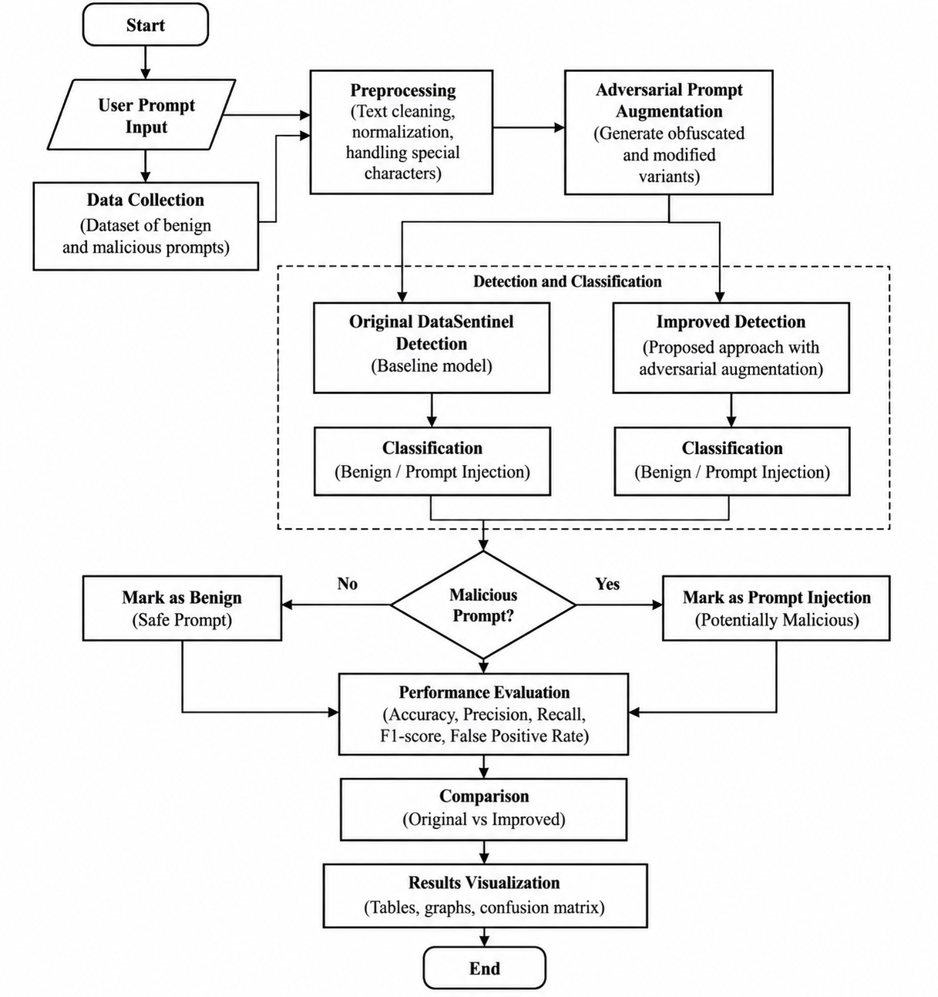
- Start: The system begins the prompt injection detection process.
- User Prompt Input: A user provides a prompt to the system.
- Data Collection: A dataset containing benign and malicious prompts is collected.
- Preprocessing: Prompts are cleaned, normalized, and special characters are handled.
- Adversarial Prompt Augmentation: Modified and obfuscated versions of prompts are generated to improve detection against variations of attacks.
- Original DataSentinel Detection: The original DataSentinel model detects potential prompt injections as the baseline approach.
- Improved Detection: The proposed model uses adversarially augmented data to improve detection performance.
- Classification: Both approaches classify prompts as Benign or Prompt Injection.
- Malicious Prompt Decision: The system determines whether the input is malicious.
- Mark as Benign: Safe prompts are classified as benign.
- Mark as Prompt Injection: Malicious prompts are identified as potential prompt injection attacks.
- Performance Evaluation: Both models are evaluated using accuracy, precision, recall, F1-score, and false-positive rate.
- Comparison: The original DataSentinel model is compared with the improved approach.
- Results Visualization: Results are presented using tables, graphs, and confusion matrices.
- End: The process is completed after displaying and comparing the results.

UML Diagrams
- Use Case Diagram
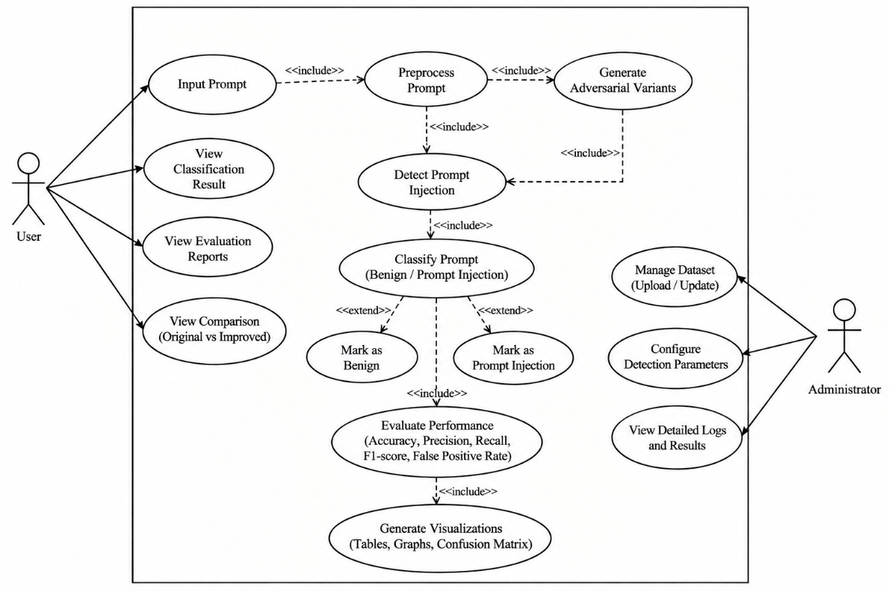
- User: Enters prompts and views the detection and evaluation results.
- Administrator: Manages datasets, detection settings, and detailed system results.
- Input Prompt: Accepts the prompt that needs to be analyzed.
- Preprocess Prompt: Cleans and normalizes the input prompt before detection.
- Generate Adversarial Variants: Creates modified or obfuscated versions of prompts for robustness testing.
- Detect Prompt Injection: Uses the DataSentinel-based detector to identify possible prompt injections.
- Classify Prompt: Classifies the prompt as Benign or Prompt Injection.
- Mark as Benign: Records the prompt as safe when it is classified as benign.
- Mark as Prompt Injection: Records the prompt as potentially malicious when detected.
- Evaluate Performance: Calculates accuracy, precision, recall, F1-score, and false-positive rate.
- Generate Visualizations: Displays results through tables, graphs, and confusion matrices.
- View Classification Result: Allows the user to see whether the prompt is benign or a prompt injection.
- View Evaluation Reports: Allows the user to view system performance.
- View Comparison: Shows the comparison between the original DataSentinel and improved approach.
- Manage Dataset: Allows the administrator to upload or update prompt-injection datasets.
- Configure Detection Parameters: Allows the administrator to adjust detection-related settings.
- View Detailed Logs and Results: Allows the administrator to inspect detailed system outputs.

- Class Diagram
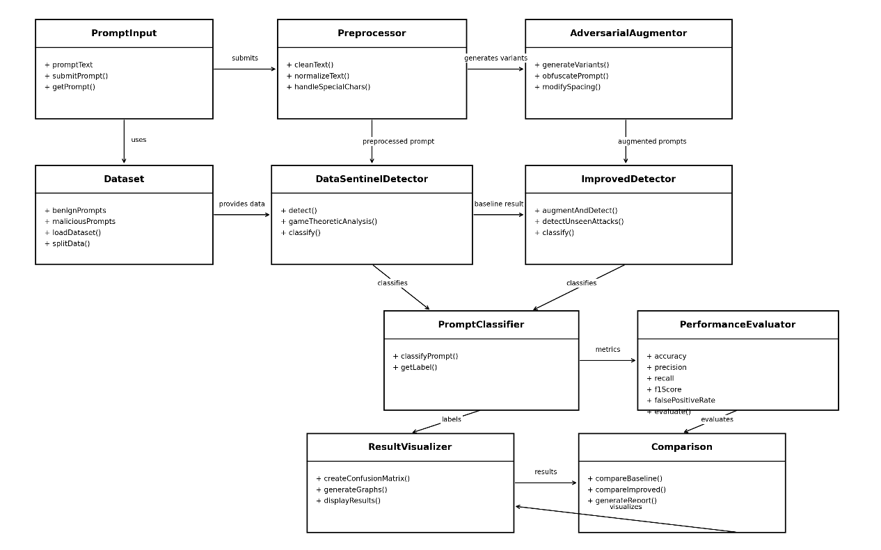
- PromptInput: Accepts the user prompt and sends it for analysis.
- Dataset: Stores benign and malicious prompts used for training and testing.
- Preprocessor: Cleans and normalizes the input prompt.
- AdversarialAugmentor: Creates modified and obfuscated versions of prompts.
- DataSentinelDetector: Performs the original DataSentinel-based prompt injection detection.
- ImprovedDetector: Uses adversarial augmentation to improve detection of difficult and unseen attacks.
- PromptClassifier: Classifies the prompt as Benign or Prompt Injection.
- PerformanceEvaluator: Calculates accuracy, precision, recall, F1-score, and false-positive rate.
- Comparison: Compares the performance of the original and improved detection approaches.
- ResultVisualizer: Displays the results using graphs, tables, and confusion matrices.

- Activity Diagram

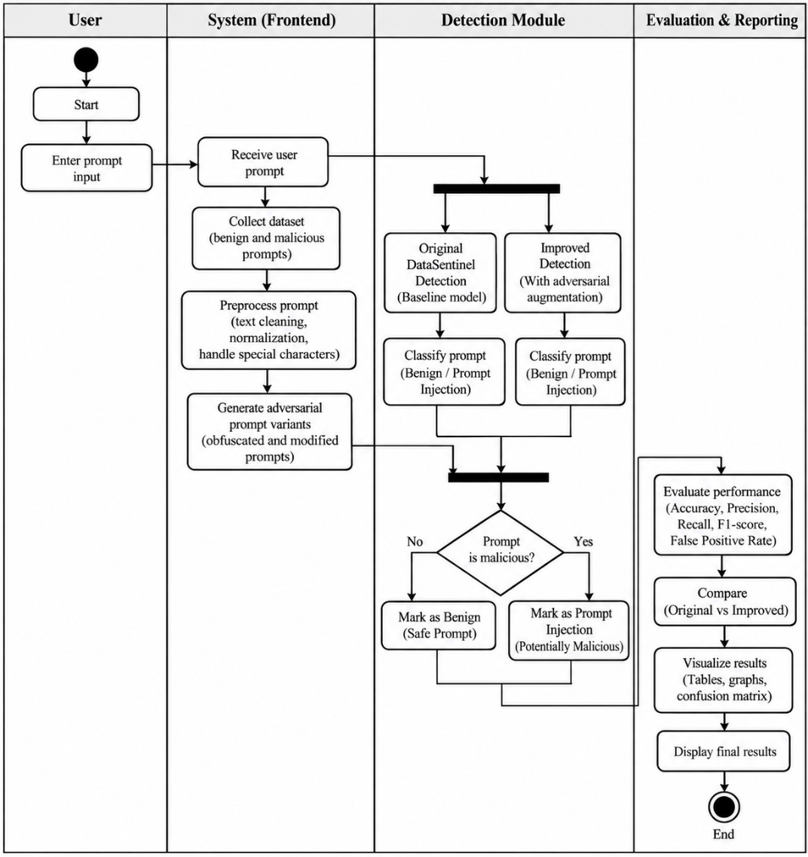
- User: Enters the prompt.
- System: Receives the prompt, collects data, preprocesses it, and generates adversarial variants.
- Detection Module: Runs both Original DataSentinel and Improved Detection.
- Classification: Classifies prompts as Benign or Prompt Injection.
- Decision: Determines whether the prompt is malicious.
- Evaluation: Calculates Accuracy, Precision, Recall, F1-score, and False Positive Rate.
- Comparison: Compares the original and improved approaches.
- Visualization: Displays tables, graphs, and confusion matrices.

